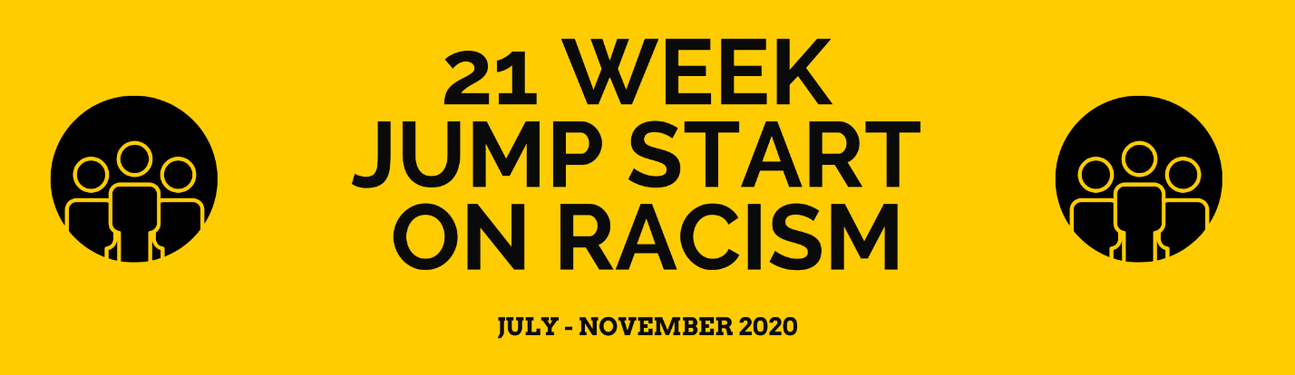

You are encouraged to hold this study and discussion with your church, friends, family, and neighbors. If you would like to participate with others across the district, you are welcome to join in the district zoom class and discussion. You can invite others, who are not members of the church, to join in this discussion with the district.

PORCH MEETINGS AT PASTOR MATT’S: TUESDAYS AT 6:00 PM (CST)
July 7, 14, 21, 28
Aug 25
Oct 6
Nov 10
Nov 17

DISTRICT ZOOM MEETINGS: WEDNSDAYS AT 5:00 PM (CST)
July 1, 8, 15, 22, 29
Aug 26
Oct 7
Nov 11
Nov 18

ZOOM LINK:

GUIDELINES FOR MEETINGS
We are talking about topics that are hard for many, stretch us to new understandings, and shake up our worldview. Let us remain open and employ John Wesley’s Christian Conferencing Guidelines

1. Respect others, as Jesus would have done when he was here on earth.
2. Pray for others as well as yourself, especially those with whom you disagree.
3. Listen to others before thinking about what you want to say in response.
4. Understand what others are saying so clearly that you could accurately state their
view.
5. Share your own point of view with grace and humility, as well as honesty and
candor.
6. Focus your comments on issues being discussed, not on persons expressing them.
7. Commit yourself to the unity of the Spirit, seeking consensus whenever possible.
8. Give the time needed to work through the process in which you are engaged.
9. Acknowledge that you may be wrong, even when you think you are right.
10. Allow the fruit of the Spirit to permeate your way of interacting with others: love, joy,
peace, patience, kindness, generosity, faithfulness, gentleness, and self-control.
Approved by the Indiana Conference UMC May 29, 2014

TRACKING CHART
WEEK | Read | Watch/Listen | Notice/Recognize | Engage/Act | Reflect
MEET 1
MEET 2
MEET 3
MEET 4
MEET 5
6
7
8
MEET 9
10
11
12
13
14
MEET 15
16
17
18
19
MEET 20
MEET 21

WEEK 1
PREPARATION
1) In preparation for the first discussion please take the Harvard implicit bias test. https://implicit.harvard.edu/implicit/selectatest.html

2) And watch Immaculate Perception: Jerry Yang at TEDxSanDiego 2013 (14 minutes) Video: https://www.youtube.com/watch?v=9VGbwNI6Ssk&feature=youtu.be

If you are interested in learning more, please feel free to do that. Here are some other resources to get you started.
Other Resources:
Jennifer Ebehart (unconscious bias): https://www.youtube.com/watch?v=YMX0QzHbSOU (1 hour)

Unconscious Bias Training—$20 class https://www.gcorr.org

3) Mark that you have watched and noticed on the tracking chart.

4) Please write your reflections below:

WEEK 2
PREPARATION

1) In preparation for the first discussion please WATCH video about White Fragility: https://www.youtube.com/watch?v=h7mzj0cVL0Q&feature=emb_share&fbclid=IwAR0G6f2J9DhI1T-xo3PhC_MUT0M26iKyHuqZKPni1U6BqrjrGIOj2P_R29o

2) Take the privilege test to NOTICE/RECOGNIZE your own privilege. Remember, privilege is okay to admit but we need to be aware of it and use it to help others. https://www.buzzfeed.com/regajha/how-privileged-are-you

3) Remember to fill out your chart.

4) Please write your reflections below:

WEEK 3
PREPARATION
1) In preparation for the first discussion please watch video 13th on Netflix or YouTube. https://www.youtube.com/watch?v=krfcq5pF8u8&fbclid=IwAR3b3pZZR6ESz9CsC2xqbIAty03-i4UTT2YG1ogwDWksyloUpfZTLSPA17Q

2) Engage/Act on what you have learned. Visit https://5calls.org/issue/justice-policing-act-booker-harris

3) Remember to fill out your chart.

4) Please write your reflections below:

WEEK 4
PREPARATION

1) In preparation for the first discussion please listen to “How to be an Anti-Racist”— (1 hour podcast)
https://brenebrown.com/podcast/brene-with-ibram-x-kendi-on-how-to-be-an-antiracist/
Here, the author provides and introduction to some concepts within the book. He also talks about how the book pushes at both conservatives and liberals.

2) Review Wesley’s Christian Conferencing Guidelines. Consider how to employ them in your discussions involving politics.

3) Remember to fill out your chart.

4) Please write your reflections below:

WEEK 5
PREPARATION
1) In preparation for this weeks class/discussion, begin to consider what you need to confess and repent of and prepare for a time of fasting and repentance.

2) Check out one of the “Other Resources” listed below.

OTHER RESOURCES:
Oprah’s 2 part series “Where Do We Go From Here”
Part 1: https://www.youtube.com/watch?time_continue=3&v=09ysfL2SlHo&feature=emb_logo
Part 2: https://www.youtube.com/watch?v=1jy6LpivqIM
https://www.inverse.com/article/41221-black-history-month-netflix-tv-film-television-shows
Bryan Stevenson (criminal justice): https://www.ted.com/talks/bryan_stevenson_we_need_to_talk_about_an_injustice?language=en
Michelle Alexander (criminal justice): https://www.youtube.com/watch?v=SQ6H-Mz6hgw
Richard Rothstein (racist housing laws): https://www.npr.org/2017/05/17/528822128/the-color-of-law-details-how-u-s-housing-policies-created-segregation
Austin Channing Brown tv show, episode with Brene Brown: https://vimeo.com/371303441
Jennifer Ebehart (unconscious bias): https://www.youtube.com/watch?v=YMX0QzHbSOU
https://www.gcorr.org
https://pulitzercenter.org/lesson-plan-grouping/1619-project-curriculum
https://www.pbs.org/newshour/nation/watch-live-race-matters-america-in-crisis-a-pbs-newshour-special
https://medium.com/equality-includes-you/what-white-people-can-do-for-racial-justice-f2d18b0e0234
https://kairoscenter.org/sermons-bible-studies-liturgies/
https://www.umcjustice.org/articles/a-charter-for-racial-justice-in-an-interdependent-global-community-136
https://www.umcjustice.org/who-we-are/social-principles-and-resolutions/white-privilege-in-the-united-states-3376
https://www.unitedmethodistwomen.org/download-resources/racial-justice-tools-for-leaders.pdf

3) Remember to fill out your chart.

4) Please write your reflections below:

Our meeting this week will be a prayer service.
We will spend time in confession and repentance.

WEEKS 6-21: HOW TO BE AN ANTIRACIST

We will now begin a book study of Ibram X Kendi’s “How to be an Anti-Racist.” Instead of meeting weekly via zoom, we will be meeting approximately once per month. If you are meeting with neighbors, friends, or your church, we encourage you to continue to meet weekly for discussions.

Here is our suggested reading pattern for the next few weeks. We will discuss what we have learned in chapters 1-7 as well as how we are noticing and engaging.

Please continue to fill out your 21 week chart and be prepared to share.

Week 6: How to be an Antiracist
Introduction—My Racist Introduction
Chapter 1—Definitions
Reflection:

Week 7: How to be an Antiracist
Chapter 2—Dueling Consciousness
Chapter 3—Power
Reflection:

Week 8: How to be an Antiracist
Chapter 4—Biology
Chapter 5—Ethnicity
Reflection:

Week 9: How to be an Antiracist
Chapter 6—Body
Chapter 7—Culture
Reflection:

Week 10: How to be an Antiracist
Chapter 8—Behavior
Reflection:

Week 11: How to be an Antiracist
Chapter 9—Color
Reflection:

Week 12: How to be an Antiracist
Chapter 10—White
Reflection:

Week 13: How to be an Antiracist
Chapter 11—Black
Reflection:

Week 14: How to be an Antiracist
Chapter 12—Class
Reflection:

Week 15: How to be an Antiracist
Chapter 13—Space
Reflection:

Week 16: How to be an Antiracist
Chapter 14—Gender
Chapter 15—Sexuality
Reflection:

Week 17: How to be an Antiracist
Chapter 16—Failure
Reflection:

Week 18: How to be an Antiracist
Chapter 17—Success
Reflection:

Week 19: How to be an Antiracist
Chapter 18—Survival
Reflection:

Week 20: How to be an Antiracist
Conclusion of Book
Reflection:

Week 21: MOVING FORWARD NOV 18 6pm
Reflection:

Start a new chart & invite others to join you!
WEEK | Read | Watch/Listen | Notice/Recognize | Engage/Act | Reflect
1
2
3
4
5
6
7
8
9
10
11
12
13
14
15
16
17
18
19
20
21

